|  |  |
| --- | --- |
| |  | | --- | |  | |
|  |
| March 22, 2017 |
| Springboard Final Project Report |
| Cognitive Tasks in Presence of Emotion/Other Distractors |
| Final report – Eric Fuhrman |
| Eric Fuhrman |

# Springboard Final Project Report

## Cognitive Tasks in Presence of Emotion/Other Distractors

Eric Fuhrman

### Introduction

A group of 94 Stanford University undergraduate and graduate students were given a series of personality assessments as well as a computerized set of cognitive tasks. These cognitive tasks included stimulus words presented during the task, which were designed to impact the participants’ performance on those tasks. The task performance data was recorded using E-Prime software and the results exported to text files for parsing. The personality assessments were coded into Microsoft Excel files by researchers at Stanford.

The researchers are interested in whether or not the personality traits measured by the assessments and the stimulus words presented during the tasks themselves impact the participants’ performance on the tasks, and in what way.

### Description and Gathering of Data

The cognitive tasks were presented automatically to participants in a timed series by a program called E-Prime, a standard behavioral research tool used in psychology research. E-Prime presents task information in predetermined series, with the order of tasks in each series randomized. In this test, as each stimulus is presented, the participant is instructed to push an answer button on the data capture machine. The E-Prime captures the details of the response in its database. Each series consists of 20 individual tasks. The details of the nature of the matching task and what constitutes a correct answer have not been provided, my analysis will be done “blind” to that detail. The research area involved in the task is to measure the interference of the emotional content of the stimulus word to the performance of the task, so while the correctness of the response to each task is measured, the focus of my analysis is more on the response time. The E-Prime program captured detail information about each task. The relevant data points gathered were:

* Subject number: Identifying number assigned to each participant before testing began.
* Running: The list number of the series being processed.
* Stimulus: The prompt word presented to the participant for the task. The stimulus word can be a positive word, a negative word, or emotionally neutral.
* StimulusDisplay.RT: The time in milliseconds from the time the stimulus was presented to the time an answer button was pressed.
* StimulusDisplay.RESP: The option selected by the participant for that task.
* CorrectAnswer: Which option is the correct answer for this task.

The e-Prime program records the data in its internal database, which is then extracted into a text file for parsing. The format of the text file is as follows for each task:

Level: 3

*** LogFrame Start ***

Stimulus: controlled

CorrectAnswer: q

Procedure: TrialProc

List1: 11

Running: List1

List1.Cycle: 1

List1.Sample: 6

StimulusDisplay.RTTime: 201411

StimulusDisplay.ACC: 1

StimulusDisplay.RT: 1588

StimulusDisplay.RESP: q

StimulusDisplay.CRESP: q

*** LogFrame End ***

I have parsed the text files in Python and saved them into a data frame for analysis.

The personality assessments were pen-and-paper questionnaires collected and graded by members of the research team. The end scoring of the assessment is reflected in a series of 25 ratings for each participant. Some of the ratings are organized into groups, with a group overall rating and details ratings. The specific meanings of the ratings have not been provided, other than the groupings. Again, all analysis will be done “blind” to that information. The ratings are as follows (sub-ratings are indented underneath their related overall rating):

ACS_mean

ARS_mean

COPE_behav_disengagement

COPE_ment_disengagement

EC_total

EC_angry

EC_anxious

ics

ics_an

PSS_mean

PSWQ_worry

RFQ_mean

RRQ_rum

RRS_brooding

RRS_pondering

rum_tre_mean

rum_nolen_mean

STAXI_mean

TCQ_mean

TCQ_distraction

TCQ_worry

TSWB_mean

TSWB_distraction

TSWB_intrusive

TSWB_suppression

The net scores of each participant, along with the subject number, was provided in an Excel spreadsheet.

### Data Cleaning and Review

After loading the data, the variable of interest (response time) was reviewed for null values. After finding none, I reviewed the distribution of the response time values, shown in Figure 1.

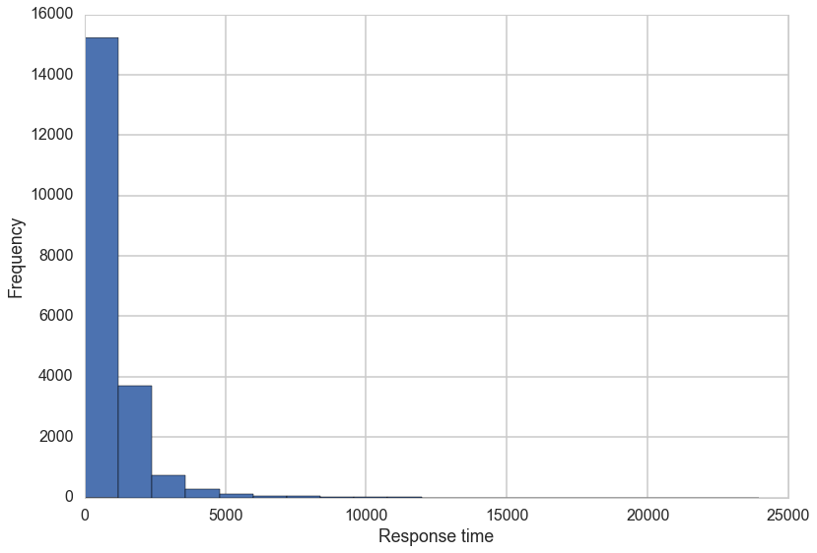

Figure 1

This distribution is extremely left-skewed, with a very long right tail. To correct this, I log-transformed the response time, which resulted in more workable distribution, shown in Figure 2.

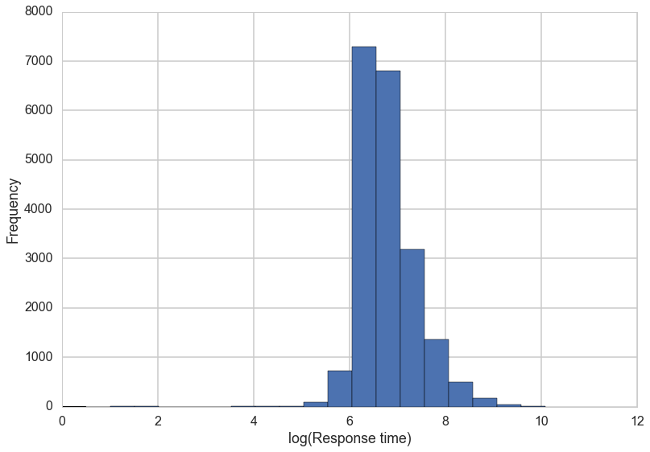

Figure 2

With the number of personality variables, I was most concerned with collinearity between the variables, so I reviewed a scatterplot matrix of the most relevant selection of main scores for distribution and correlation, shown in Figure 3.

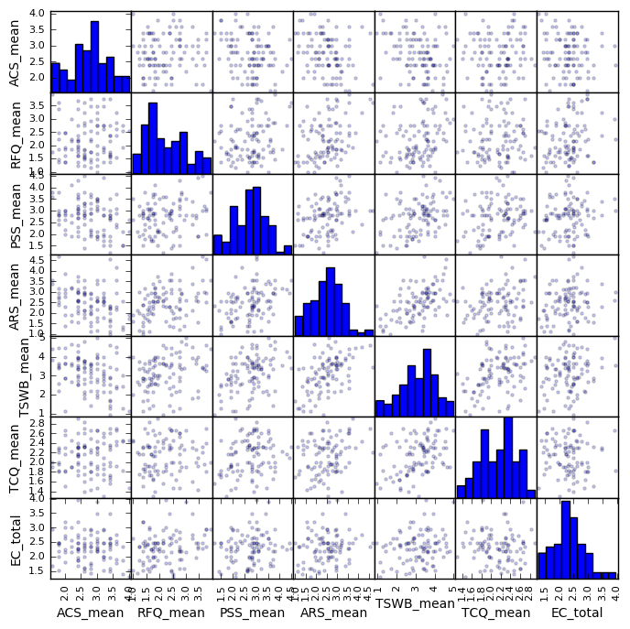

Figure 3

All of the variables appear to be reasonably normal, with no problematic outliers, and no significant collinearity was observed, with the exception of TSWB_mean and ARS_mean. Caution will be used for any model that includes both of those terms. For personality factors that are part of the same grouping, a review was done to determine the relationship between the variables.

As an example, in Figure 4 is a scatterplot matrix of the TSWB scores.

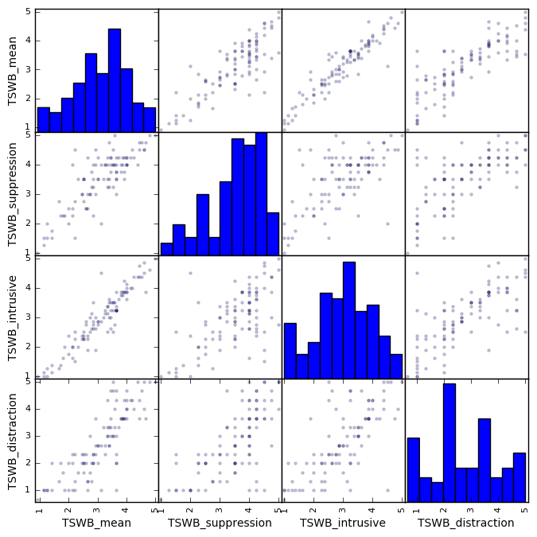

Figure 4

As I would have expected, the variables are very highly correlated, especially TSWB_intrusive and TSWB_mean. For that reason, I did not include multiple factors from the same group in any model.

I also reviewed the personality scores for null values, and found that some participants did not have all the scores determined, because of incomplete answers. Those participants will be excluded from any model that uses the score involved.

As an initial review of response times, I reviewed the range of the log-Response times grouped by the stimulus word type (positive, negative, or neutral), shown in Figure 5.

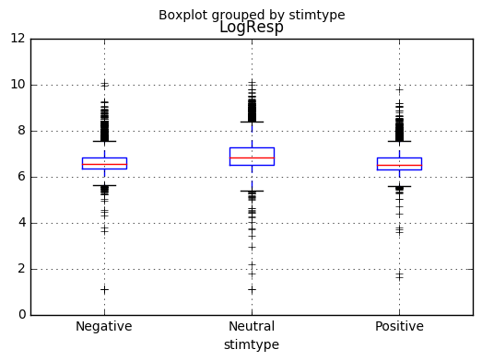

Figure 5

Surprisingly, the Neutral response times are both longer and more variable than either of the Emotional stimuli. The first set of tasks are all Neutral tasks, so I reviewed the response times by series in Figure 6.

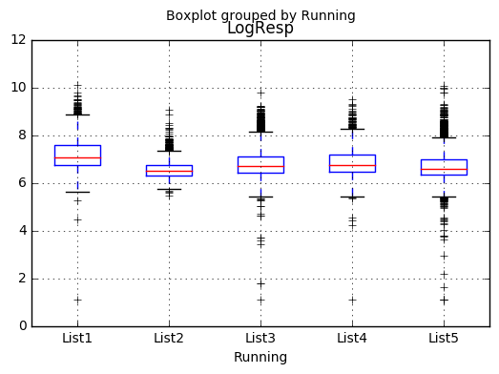

Figure 6

The first series certainly has a longer and more variable response time than the others, so I re-ran the boxplot for stimulus type excluding the first series, shown as Figure 7.

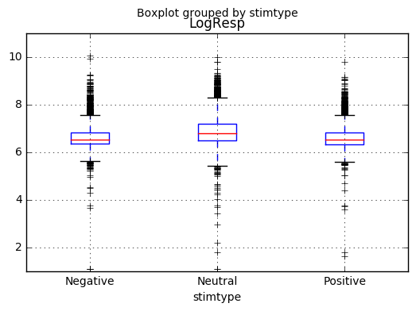

Figure 7

The pattern of longer and more variable Neutral tasks holds when List1 is excluded, so I did not exclude List1 tasks from further processing.

### Analysis

To begin the analysis, I ran a simple ordinary least squares regression between the task types, the subject, and the log of the response times. The purpose of this analysis was to determine how much variability there was between subjects that might be explained by personality characteristics. The coefficients of the model are:

|  |  |  |  |  |  |  |
| --- | --- | --- | --- | --- | --- | --- |
|  |  |  |  |  | **95% Confidence Int** | |
| **Feature** | **Coefficient** | **Std Error** | **t-value** | **p-value** | **Lower Limit** | **Upper Limit** |
| Intercept | 6.575 | 0.031 | 214.804 | 0.000 | 6.515 | 6.635 |
| stimtype[T.Neutral] | 0.244 | 0.008 | 30.827 | 0.000 | 0.229 | 0.260 |
| stimtype[T.Positive] | -0.019 | 0.009 | -2.003 | 0.045 | -0.037 | 0.000 |
| Subject[T.010] | 0.019 | 0.042 | 0.454 | 0.650 | -0.064 | 0.102 |
| Subject[T.013] | 0.056 | 0.043 | 1.320 | 0.187 | -0.027 | 0.140 |
| Subject[T.014] | 0.006 | 0.043 | 0.143 | 0.886 | -0.077 | 0.090 |
| Subject[T.015] | 0.223 | 0.043 | 5.222 | 0.000 | 0.139 | 0.307 |
| Subject[T.016] | -0.072 | 0.043 | -1.690 | 0.091 | -0.155 | 0.011 |
| Subject[T.019] | 0.003 | 0.042 | 0.072 | 0.942 | -0.080 | 0.086 |
| Subject[T.022] | 0.146 | 0.043 | 3.407 | 0.001 | 0.062 | 0.230 |
| Subject[T.026] | 0.074 | 0.043 | 1.724 | 0.085 | -0.010 | 0.157 |
| Subject[T.030] | -0.235 | 0.042 | -5.535 | 0.000 | -0.318 | -0.152 |
| Subject[T.032] | 0.149 | 0.044 | 3.400 | 0.001 | 0.063 | 0.235 |
| Subject[T.035] | 0.179 | 0.042 | 4.222 | 0.000 | 0.096 | 0.263 |
| Subject[T.038] | 0.081 | 0.043 | 1.884 | 0.060 | -0.003 | 0.165 |
| Subject[T.039] | 0.075 | 0.043 | 1.747 | 0.081 | -0.009 | 0.159 |
| Subject[T.040] | 0.201 | 0.043 | 4.711 | 0.000 | 0.117 | 0.284 |
| Subject[T.043] | -0.014 | 0.043 | -0.331 | 0.741 | -0.098 | 0.070 |
| Subject[T.052] | 0.213 | 0.043 | 4.965 | 0.000 | 0.129 | 0.296 |
| Subject[T.053] | -0.102 | 0.042 | -2.403 | 0.016 | -0.185 | -0.019 |
| Subject[T.056] | 0.183 | 0.043 | 4.226 | 0.000 | 0.098 | 0.268 |
| Subject[T.061] | 0.297 | 0.043 | 6.876 | 0.000 | 0.212 | 0.381 |
| Subject[T.064] | 0.212 | 0.043 | 4.897 | 0.000 | 0.127 | 0.297 |
| Subject[T.065] | -0.161 | 0.042 | -3.789 | 0.000 | -0.244 | -0.078 |
| Subject[T.068] | -0.095 | 0.043 | -2.222 | 0.026 | -0.179 | -0.011 |
| Subject[T.069] | -0.527 | 0.043 | -12.356 | 0.000 | -0.610 | -0.443 |
| Subject[T.070] | 0.086 | 0.043 | 2.029 | 0.043 | 0.003 | 0.170 |
| Subject[T.071] | 0.179 | 0.044 | 4.024 | 0.000 | 0.092 | 0.266 |
| Subject[T.074] | -0.175 | 0.043 | -4.102 | 0.000 | -0.259 | -0.091 |
| Subject[T.078] | -0.204 | 0.042 | -4.790 | 0.000 | -0.287 | -0.120 |
| Subject[T.079] | 0.086 | 0.043 | 2.018 | 0.044 | 0.002 | 0.170 |
| Subject[T.085] | -0.174 | 0.042 | -4.093 | 0.000 | -0.257 | -0.091 |
| Subject[T.087] | -0.367 | 0.042 | -8.625 | 0.000 | -0.450 | -0.283 |
| Subject[T.089] | -0.409 | 0.042 | -9.624 | 0.000 | -0.492 | -0.326 |
| Subject[T.093] | -0.051 | 0.043 | -1.199 | 0.231 | -0.135 | 0.032 |
| Subject[T.096] | 0.082 | 0.043 | 1.933 | 0.053 | -0.001 | 0.166 |
| Subject[T.098] | -0.066 | 0.042 | -1.559 | 0.119 | -0.150 | 0.017 |
| Subject[T.101] | 0.203 | 0.043 | 4.750 | 0.000 | 0.119 | 0.287 |
| Subject[T.104] | -0.062 | 0.043 | -1.447 | 0.148 | -0.146 | 0.022 |
| Subject[T.105] | 0.011 | 0.042 | 0.262 | 0.793 | -0.072 | 0.094 |
| Subject[T.106] | -0.046 | 0.042 | -1.080 | 0.280 | -0.129 | 0.037 |
| Subject[T.109] | 0.431 | 0.044 | 9.706 | 0.000 | 0.344 | 0.518 |
| Subject[T.111] | -0.003 | 0.043 | -0.077 | 0.939 | -0.087 | 0.081 |
| Subject[T.112] | 0.111 | 0.043 | 2.590 | 0.010 | 0.027 | 0.194 |
| Subject[T.113] | -0.115 | 0.043 | -2.694 | 0.007 | -0.198 | -0.031 |
| Subject[T.114] | -0.081 | 0.043 | -1.899 | 0.058 | -0.165 | 0.003 |
| Subject[T.116] | -0.463 | 0.042 | -10.913 | 0.000 | -0.546 | -0.380 |
| Subject[T.117] | 0.117 | 0.043 | 2.727 | 0.006 | 0.033 | 0.201 |
| Subject[T.118] | 0.041 | 0.042 | 0.974 | 0.330 | -0.042 | 0.125 |
| Subject[T.119] | 0.005 | 0.043 | 0.125 | 0.901 | -0.078 | 0.089 |
| Subject[T.121] | -0.087 | 0.042 | -2.050 | 0.040 | -0.170 | -0.004 |
| Subject[T.123] | -0.151 | 0.042 | -3.555 | 0.000 | -0.234 | -0.068 |
| Subject[T.124] | -0.231 | 0.043 | -5.392 | 0.000 | -0.315 | -0.147 |
| Subject[T.126] | -0.065 | 0.042 | -1.534 | 0.125 | -0.148 | 0.018 |
| Subject[T.128] | -0.054 | 0.043 | -1.271 | 0.204 | -0.138 | 0.030 |
| Subject[T.129] | -0.069 | 0.043 | -1.614 | 0.106 | -0.153 | 0.015 |
| Subject[T.130] | 0.151 | 0.045 | 3.349 | 0.001 | 0.063 | 0.239 |
| Subject[T.131] | -0.290 | 0.042 | -6.825 | 0.000 | -0.373 | -0.207 |
| Subject[T.132] | -0.028 | 0.043 | -0.646 | 0.518 | -0.112 | 0.056 |
| Subject[T.133] | 0.064 | 0.043 | 1.506 | 0.132 | -0.019 | 0.148 |
| Subject[T.134] | 0.028 | 0.043 | 0.653 | 0.514 | -0.056 | 0.112 |
| Subject[T.135] | -0.121 | 0.042 | -2.844 | 0.004 | -0.204 | -0.038 |
| Subject[T.136] | -0.192 | 0.043 | -4.510 | 0.000 | -0.275 | -0.108 |
| Subject[T.137] | 0.078 | 0.043 | 1.802 | 0.072 | -0.007 | 0.163 |
| Subject[T.138] | 0.194 | 0.043 | 4.556 | 0.000 | 0.110 | 0.277 |
| Subject[T.139] | -0.347 | 0.042 | -8.156 | 0.000 | -0.430 | -0.263 |
| Subject[T.141] | -0.081 | 0.043 | -1.905 | 0.057 | -0.164 | 0.002 |
| Subject[T.142] | 0.039 | 0.043 | 0.897 | 0.370 | -0.046 | 0.123 |
| Subject[T.143] | 0.047 | 0.042 | 1.097 | 0.273 | -0.037 | 0.130 |
| Subject[T.145] | 0.228 | 0.045 | 5.077 | 0.000 | 0.140 | 0.316 |
| Subject[T.146] | 0.183 | 0.043 | 4.240 | 0.000 | 0.098 | 0.267 |
| Subject[T.147] | -0.072 | 0.042 | -1.692 | 0.091 | -0.155 | 0.011 |
| Subject[T.149] | -0.486 | 0.043 | -11.405 | 0.000 | -0.569 | -0.402 |
| Subject[T.151] | 0.285 | 0.043 | 6.639 | 0.000 | 0.201 | 0.369 |
| Subject[T.152] | 0.058 | 0.044 | 1.328 | 0.184 | -0.028 | 0.143 |
| Subject[T.155] | 0.293 | 0.044 | 6.708 | 0.000 | 0.207 | 0.378 |
| Subject[T.156] | 0.458 | 0.045 | 10.114 | 0.000 | 0.370 | 0.547 |
| Subject[T.157] | 0.102 | 0.043 | 2.385 | 0.017 | 0.018 | 0.186 |
| Subject[T.158] | 0.057 | 0.043 | 1.340 | 0.180 | -0.026 | 0.141 |
| Subject[T.159] | 0.004 | 0.043 | 0.093 | 0.926 | -0.080 | 0.087 |
| Subject[T.160] | 0.203 | 0.043 | 4.776 | 0.000 | 0.120 | 0.287 |
| Subject[T.161] | 0.253 | 0.043 | 5.925 | 0.000 | 0.169 | 0.337 |
| Subject[T.163] | 0.101 | 0.042 | 2.383 | 0.017 | 0.018 | 0.185 |
| Subject[T.164] | -0.562 | 0.043 | -13.189 | 0.000 | -0.646 | -0.479 |
| Subject[T.165] | 0.252 | 0.043 | 5.881 | 0.000 | 0.168 | 0.336 |
| Subject[T.166] | 0.412 | 0.046 | 8.929 | 0.000 | 0.321 | 0.502 |
| Subject[T.168] | 0.142 | 0.043 | 3.286 | 0.001 | 0.057 | 0.227 |
| Subject[T.175] | 0.147 | 0.043 | 3.388 | 0.001 | 0.062 | 0.231 |
| Subject[T.37] | 0.164 | 0.043 | 3.810 | 0.000 | 0.080 | 0.249 |
| Subject[T.66] | 0.133 | 0.043 | 3.084 | 0.002 | 0.049 | 0.218 |
| Subject[T.84] | 0.430 | 0.042 | 10.120 | 0.000 | 0.347 | 0.513 |
| Subject[T.88] | 0.055 | 0.043 | 1.286 | 0.198 | -0.029 | 0.139 |
| Subject[T.90] | 0.024 | 0.042 | 0.573 | 0.567 | -0.059 | 0.107 |
| Subject[T.97] | 0.039 | 0.042 | 0.906 | 0.365 | -0.045 | 0.122 |

While there is a coefficient of 0.244 for Neutral tasks over Negative (baseline), you can see that there is great variance between subjects, as well as certain subjects having a large standard error (note subjects 109 and 156). Thus, it makes sense to develop models to account for that difference between subjects based on the personality metrics collected.

Since there are multiple observations for every subject, the observations are not all independent, which is a requirement for linear regression. Therefore, I used a Linear Mixed Model to model the data, which controls for the effect of each subject as a separate group within the data. Each of the personality measures was modeled against the log of the response time, and statistically insignificant features (p-value > .05) were removed from the model. The model included both the effect of the personality measure as well as an interaction term with the stimulus type. Listing all of those iterations would be too voluminous for this report, but as an example, here are the results of one of the preliminary models:

|  |  |  |  |  |  |  |
| --- | --- | --- | --- | --- | --- | --- |
|  |  |  |  |  | **95% Confidence Int** | |
| **Feature** | **Coefficient** | **Std Error** | **z-value** | **p-value** | **Lower Limit** | **Upper Limit** |
| Intercept | 6.956 | 0.252 | 27.656 | 0.000 | 6.463 | 7.449 |
| stimtype[T.Neutral] | 0.202 | 0.056 | 3.579 | 0.000 | 0.091 | 0.312 |
| stimtype[T.Positive] | 0.052 | 0.067 | 0.777 | 0.437 | -0.079 | 0.183 |
| PSS_mean | -0.077 | 0.047 | -1.662 | 0.096 | -0.169 | 0.014 |
| stimtype[T.Neutral]:PSS_mean | 0.037 | 0.017 | 2.238 | 0.025 | 0.005 | 0.070 |
| stimtype[T.Positive]:PSS_mean | -0.015 | 0.020 | -0.774 | 0.439 | -0.054 | 0.023 |
| RRQ_rum | -0.033 | 0.037 | -0.877 | 0.380 | -0.106 | 0.040 |
| stimtype[T.Neutral]:RRQ_rum | 0.026 | 0.013 | 1.943 | 0.052 | 0.000 | 0.052 |
| stimtype[T.Positive]:RRQ_rum | 0.012 | 0.016 | 0.770 | 0.441 | -0.019 | 0.043 |
| EC_total | 0.042 | 0.054 | 0.775 | 0.438 | -0.064 | 0.149 |
| stimtype[T.Neutral]:EC_total | -0.041 | 0.019 | -2.124 | 0.034 | -0.078 | -0.003 |
| stimtype[T.Positive]:EC_total | -0.031 | 0.023 | -1.374 | 0.169 | -0.076 | 0.013 |
| RFQ_mean | 0.135 | 0.038 | 3.531 | 0.000 | 0.060 | 0.209 |
| ACS_mean | -0.148 | 0.052 | -2.842 | 0.004 | -0.249 | -0.046 |
| Intercept RE | 0.054 | 0.018 |  |  |  |  |

For this iteration, the RRQ_rum variable was removed from the model for the next iteration. The significance of individual features varied significantly between iterations as other features were removed. For instance, in the above model, the EC_total feature is significant, but became insignificant in another iteration. Also, the interaction terms for some variables were removed, as they were for RFQ_mean and ACS_mean in the iteration above.

The final model results are:

|  |  |  |  |  |  |  |
| --- | --- | --- | --- | --- | --- | --- |
|  |  |  |  |  | **95% Confidence Int** | |
| **Feature** | **Coefficient** | **Std Error** | **z-value** | **p-value** | **Lower Limit** | **Upper Limit** |
| Intercept | 6.943 | 0.215 | 32.288 | 0.000 | 6.522 | 7.365 |
| stimtype[T.Neutral] | 0.164 | 0.042 | 3.915 | 0.000 | 0.082 | 0.246 |
| stimtype[T.Positive] | 0.011 | 0.050 | 0.215 | 0.830 | -0.087 | 0.108 |
| PSS_mean | -0.086 | 0.043 | -2.000 | 0.045 | -0.170 | -0.002 |
| stimtype[T.Neutral]:PSS_mean | 0.046 | 0.015 | 3.101 | 0.002 | 0.017 | 0.075 |
| stimtype[T.Positive]:PSS_mean | -0.013 | 0.018 | -0.753 | 0.451 | -0.048 | 0.021 |
| RFQ_mean | 0.122 | 0.036 | 3.425 | 0.001 | 0.052 | 0.192 |
| ACS_mean | -0.128 | 0.049 | -2.604 | 0.009 | -0.225 | -0.032 |
| Intercept RE | 0.054 | 0.017 |  |  |  |  |

The statistically significant features in the model are the Neutral stimulus type, the interaction between the Neutral stimulus type and the PSS_mean value, the RFQ_mean value, and the ACS_mean value, all with a p-value of less than .01. The PSS value is also statistically significant on its own, with a p-value of .045. The model residuals vs. the predicted values are plotted in Figure 8. The residual values are scattered evenly around zero, as expected. The histogram of the residuals is shows in Figure 9, and show a sufficiently normal distribution of residual values.

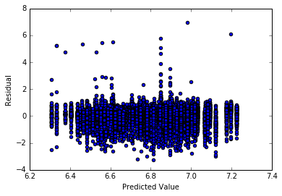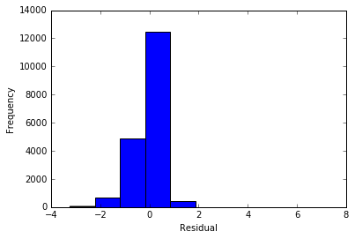

Figure 8 Figure 9

### Conclusion

The analysis above has shown that some of the tested personality traits have a statistically significant impact on participants’ response times on the tasks tested, as well as the difference between the neutral stimulus tasks and the emotion stimulus tasks.

Specifically, the participant RFQ_mean score has a positive correlation with response times (increased score correlates to longer response time), while the ACS_mean has a negative correlation (increased score correlates to shorter response time). As I noted above, the data showed a surprising result, that neutral stimuli resulted in longer response times. It is therefore perhaps most significant that PSS_mean showed a significant interaction with stimulus type, where increased PSS_mean score was correlated to a longer response time on neutral tasks.

It is beyond the scope of this analysis to hypothesize what these results might tell us about the neural processing of these tasks, but I hope that further research focusing on these specific personality traits could lead to better understanding of the underlying processing.